Step 4. Fixed Sensor Initialization
IMU sensors are exposed to different types of vibrations from the machine and other factors that may affect noise generation such as loose pins and brackets, engine vibration, etc. By performing the Fixed Sensor Initialization (FSI), the sensor data is examined and used to determine the gyro bias in the sensor, thus optimizing performance and accuracy.
If the machine is equipped with a Tilt Coupler or will be equipped with a Tilt Bucket, you will connect the Tilt sensor first. If this is currently not possible because, for example, the bucket is not on site, this step must be repeated.
1. Enter the Fixed Sensor initialization menu within the Installation Assistant
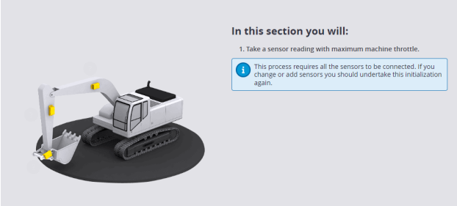
2. Position the machine as shown on-screen. The Machine must be on stable
ground, the attachment must be grounded, Throttle at maximum RPM, and the
engine at normal operation temperature to proceed.
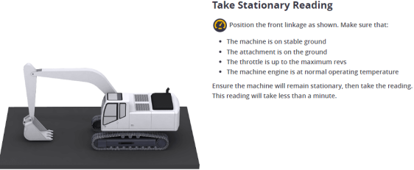
3. Select Begin Reading and allow calibration to complete.

